Making the cockpit canopy-using boiling water (MS)[17/09/2008]
Here I will describe, how to make smaller canopies for gliders and motorplanes.

It is very simple method, and depending of the material type used for the "plug-mold" , one can make just one canopy (foam plug), or many of them (wood plug).

I will describe in Part 1, how I made a canopy , then in Part 2, will show you how I made a simpliest mold from extruded styrofoam (DOW or similar)
In Part 3, I will tell you about some other variants of this technology.

Part 1.:

MAKING A CANOPY FROM PET BOTTLE, USING BOILING WATER

According to size of canopy, we use a pet plastic bottle of apropriate size.
Cut the bottom of the bottle and allso the top away.

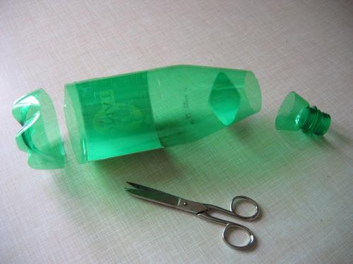

Now take your canopy positive plug (look at Part 2 on how to make it) and press fit into the bottle.

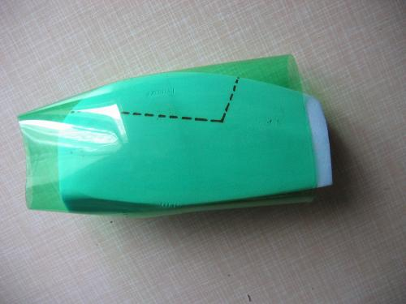
Of course, you should trim bottom of your plug to made tight fit. But not overdoo..the overthight fit can crush foam plug!

On the areas where foam and bottle are appart, pres some wedges to fill the gaps.

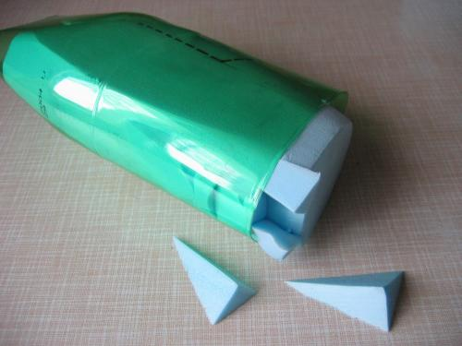
You must do that at "bottom" of the canopy plug.

Now, use fork to pierce it to the exposed foam at the bottom of the bottle. Fork will serve as a handle, at processs that follows.

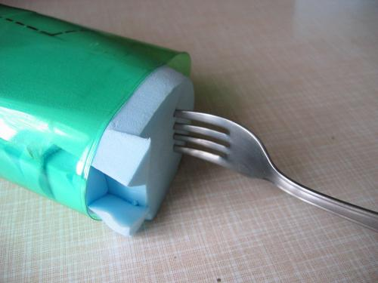

Take large enough pot, and boil the water in it. Dont fill the water up to the edge of the pot! Leave some space, as water level will rise when we dip our mold in the water!
Be very carefuly, not to boil yourself with the water!

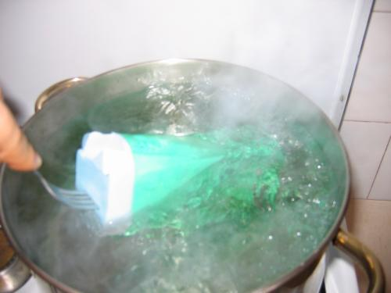
Dip your mold in the boiling water and turn it from side to side, so all plastic will recieve a heat from water.

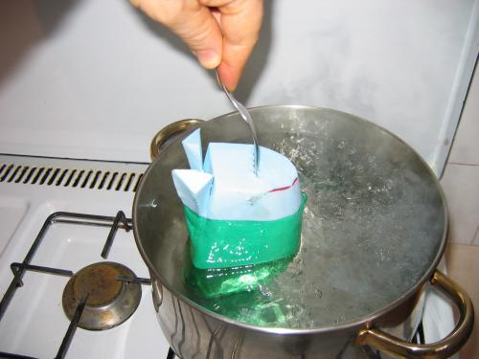
After about 30 seconds, rise mold from the water and check, how the shrinking of plastic bottle goes. If needed, dip it again into the water, until you are satisfied with its look.

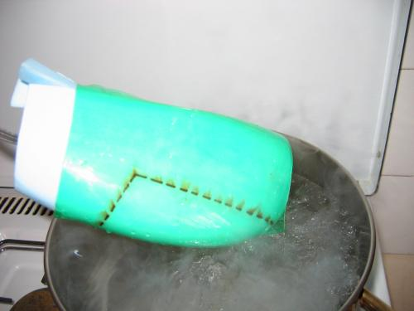

Usually it takes about 1-2 minutes to get desired result.

Often the shrinking of the bottle in the water is not sufficient at some of canopies.
Look at the front edge on photo bellow.

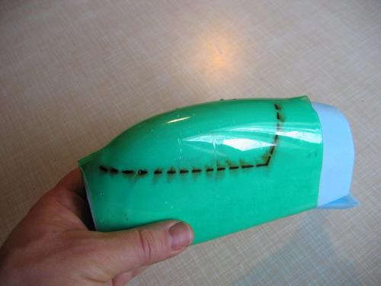
Obviously, there is needed more of shrinking!

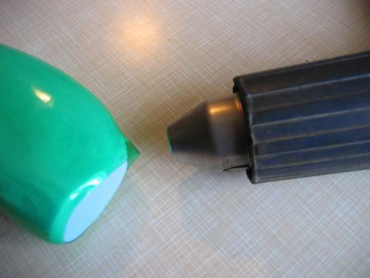

It is not a problem! We can use hot air blower (Old paint remower, not a hair dryer!) and carefully heat the area, that cause problem. But you must be very careful doing that, as foam, can melt under the heat, and you will get distorted canopy!!

Now you use sharp knife and cut the usefull part away. It is not a bad idea to mark the canopy outline on the plug and not cut slightly outsuide, so we get enough material for trimming, when assembling canopy to the model.

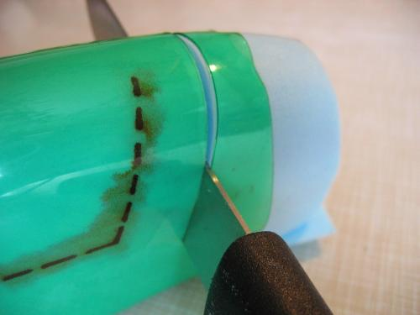

Again, be carefull, not to cut yourself!

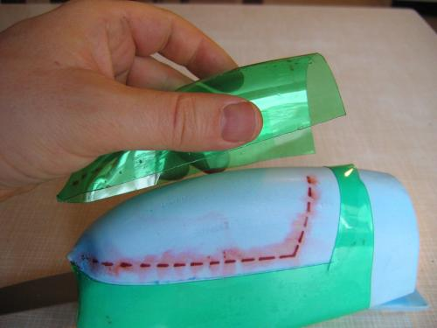

And "voila", our first canopy is allmost done!!!

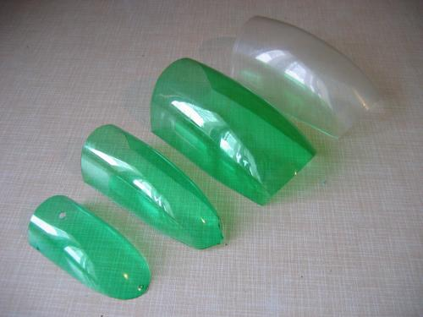
You can make many of them, different sizes, colors....

And make your model proud :)

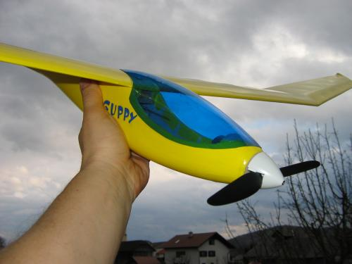

My design of electric glider Guppy, with homemade canopy, done as described above.

Part 2.:

MAKING OF THE CANOPY MOLD PLUG

Take a well sized extruded styrofoam, and shape the canopy of your plane.

The piece should be large enough, as we need to make it overzized in front, rear and bottom. We need to get so large canopy, that can be easily trimmed down to proper dimention, when fitting it to the aeroplane.

I usually take those steps:

- I draw an upper canopy contour to the foam, extending it tangentially in the front and the rear edge for an inch. Then I cut foam using very sharp kitchen knife, doing motions as on sawing. This kind of cutting motions produce a clean cut and minimum ammount of foam debris.

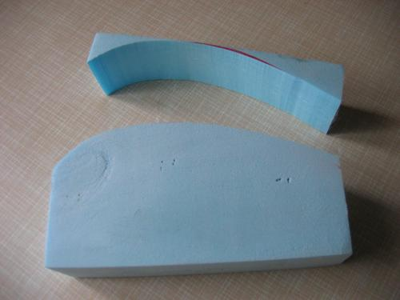
- Now I draw allso a bottom view of the canopy...ussually planform of the cockpit area. I cut same way as previous...kitchen knife.

- As canopy is ussually oval in cross section, I cut away edges. Then again cut away edges, but just a slightly.
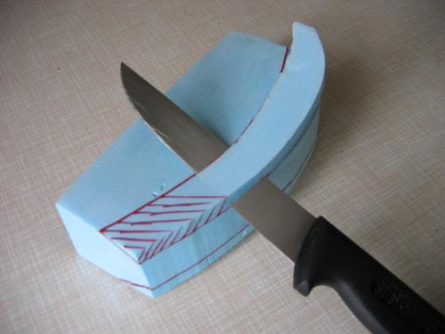
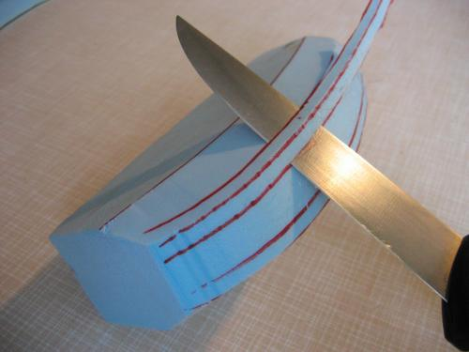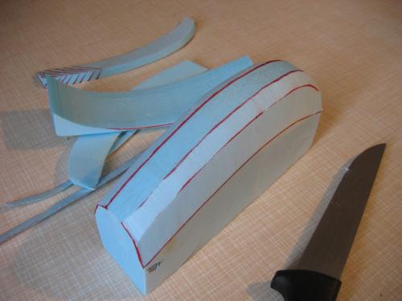

- Now I tok the sanding block and sand down the foam, until satisfied with the shape.

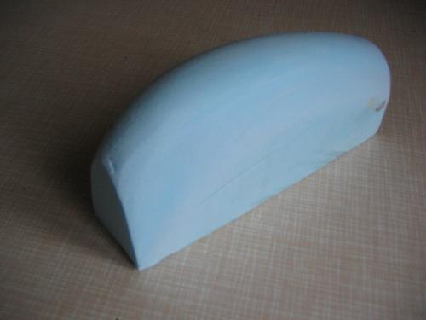
- I draw an outline of the finished canopy on the foam, so I will be able to cut away the canopy with some extra material for trimming later.

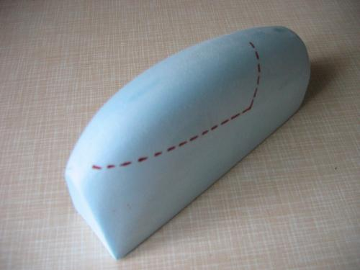

Part 3:

ADDITIONAL INFO:

The presented proces can be used in many variations. Some of them are:

1. You can make more durable and acurate plug from wood.

2. If your plug is made from wood or other heat resistant material, you dont need to use boiling water. You can shrink the bottle over wooden plug just using a heat gun.

3. When making very small or thin canopy, you can make two at once! Just carve your plug such way, that you will cerate one canopy on each side.

4. When making small canopy using shrinking method, you can allso use clear or tinted shrinking tube (those one that we wrap around batteries packs), and just use hot gun to shrink it over a plug.

But be aware, that complicated shaped canopies can not be done with this process. But as far I use it, it is very usefull for allmost any glider and normal sport plane.

I hope, that this technology will allow you to make some perfect canopies for your future project, or replacment part in case of mishap.

And once again, be carefull, when use sharp tools, and hot media...

Mitja

