MAKING CANOPY
FOR
LARGE SCALE AEROPLANE
You broke a canopy on your scale aeroplane, and no replacement is available? You are building a large aeroplane and search for a cheap and simple way to make the canopy? You have no vacuumforming equippment?
Vy výmet klenba na vašom črepinovom lietadle, a žiadna náhrada je k dispozícii?
Vy staví sa veľké lietadlo a pátra po lacný a jednoduchý ceste do realizácie klenba?
Vy nemáte žiadny prázdnota-formovanie vybavený?

Here is how I made my large canopies-the simple way!
I use a styrofoam block, and carve a canopy shape. At its edges, I made that shape (lets call it »positive mold«) larger for about 2,5 cm (1inch) so we could later trim the finished canopy to proper size.
Shaping of the positive mold starts with transfering outer contour to sides of the styrofoam block and cutting it. You can use very sharp knife (beware, not to cut yourself!!) using motions as knife was a saw. You can use hot wiring bow, going carefully over the drawn lines, or over prepared templates, made from hard paper, masonite, or other apropriate material. Now we should refine the shape, to give it proper shape (oval cross sections). We can use some cross section templates, to check our progress. I usually cut away the edges at approx 45°. Afterthat I cut again all edges. Now the canopy positive mold is comprised by about 9 surfaces. We use sandpaper or sanding block, to smooth the positive mold surface.

Ako ja som urobil veľké kopito- jednoduchá cesta!
Používam styrofoam blok, a vytvarujem tvar kabíny. Okraje-tvar som urobil väčšie asi o 2,5 cm tak aby som neskôr mohol vyrezať presnú veľkosť.
Tvarovaním kopyta docielime vonkajšie kontúry styrofoam bloku. Môžete použije veľmi ostrý nôž, použiť pohyby akoby nôž bola píla. Môžete použije teplý odporový drôt. Šablony vyrobíme z tvrdeného papiera. Môžeme používať niekoľko šablón na kontrolu nášho kopyta. Ja obyčajne odrežem okraje v pod uhlom 45°. Teraz kabína pilota obrúsime brúsnym papierom do hladka.
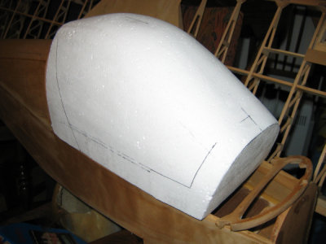
When satisfied with the shape, we must cover the surface with some kind of filler, that can be later easily sanded. If we intend to use this mold many times it is not a bad idea to strengten its outer surface. You can use glass laminate and filler if you are master in this technology.
My prefer method is more low-tech. I use white carpenter glue thinned with a water and small pieces of newspaper to cover the surface. I pour allmost milk-alike glue in a pan and troughly soak paper pieces in it. I apply about 3 layers of paper over the mold surface, and leave over night in very warm place so water from glue could evaporate. Well, somethimes take two days for evaporating the moisture from the paper skin.
Používam biele vodové stolárske lepidlo a malými kúskami novín polepíme povrch. Papier dokonale presycujem lepidlom. Aplikujem asi 3 vrstiev z papiera a nechám cez noc na teplom mieste tak aby voda z lepidla mohla sa odparovať. Dobre je počkať s ďalším opracovaním 2 dni.
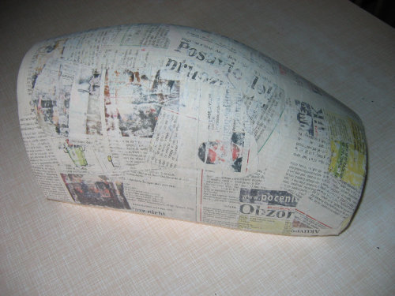
Now I sand the surface a bit, and apply filler. I use a filler that is made for wood and can be sanded easily. After each layer I leave to harden and then sand. I repeat this process for about 3 times, or until get satisfied result. I use fine grade sandpaper.
Povrch vytmelím tmelom na drevo a celý povrch obrúsim. Opakujem až do úplnej spokojnosti.
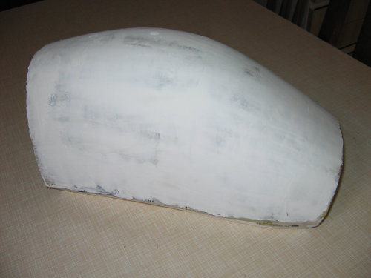

We can use that positive mold already, but we can also paint it to get smoother surface, and find out possible areas, where more filler should be applied.
Po nastriekaní sa môžu objaviť ešte drobné kazy, ktoré opravíme.
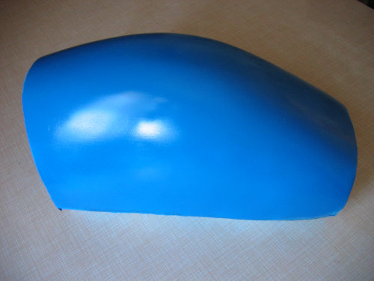
And now to the making of our canopy!
I use a 0,4mm thick thermoplastic foil. I clamp two sides between a pair of wooden sticks and use woodscrews to tight them together.
I insert a nail on each of four ends , cut their heads off, and bent it to a hook shape.
I heat the kitchen owen and insert the plastic in. I hook those bended nails into side rails of the owen, so plastic will be hanged nicely in the available space.
I look into the owen trough a windoow in the owen door. The plastic will soon starts to be soft. You will notice, that it shakes a bit under the air circulation inside the owen. The plastic will became soft and it will starts to streech under its own weight, which is visible by its lower side slowly sinking down. Plastic can also starts to look foggy. Dont worry, it will became clear later on the process by itself.
Now open the owen and grab both wooden ends (HOT!! Use safe kitchen gloves!!! Dont burn yourself!!) take it out from the owen and put over your canopy mold. Be careful and place it properly! Now push both wooden parts down. The plastic will strech and follow the mold shape. Dont ease on the down pressure.
A teraz ako zhotoviť kabínu.
Používam 0,4mm hrubú termoplastová fólia. Ja zovriem dve strany medzi pár drevených hranolov a za tieto hranoly držím pri lisovaní.
Fóliu ohrievam v elektrickej rúre kuchynského sporáka. Zavesíme za hranolčeky vo vyhriatom priestore tak , aby fólia voľne visela.
Fólia začne byť mäkká keď sa začne pohybovať v teplom prúde a predlžuje sa. Pri ohrievaní sa môže fólia matnieť, pri schladení znova sa vyčistí.
Po správnom zohriatí, za pomoci kuchynských rukavíc, chopíme za drevené hranolčeky, vyberieme a tvarujeme (primeraným tlakom) na pripravenom kopyte ťahaním smerom dole, až do vychladnutie.

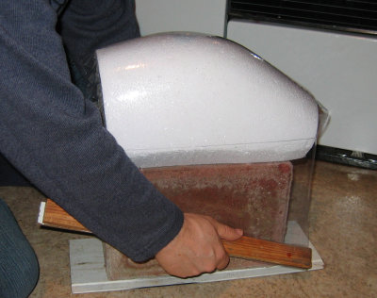
Pulling down against the mold. (here I use a mold from pure styrofoam, and resulted canopy get inprint from foam structure. I recomend to use filler on the surface!)
Zbúrajte proti charakter. (tu ja používam charakter z čistý styrofoam, a skončil nebesia pre získanie v-stopa z štruktúry pien. Ja recomend na používanie plniaci na povrchu!)

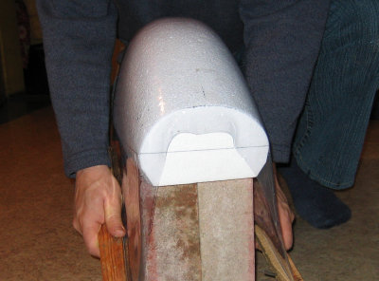

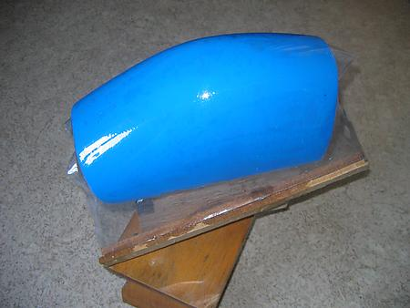
This picture show making canopy on the mold that has prepared outer surface with filledr and paint. This will brings much better results! I recoment this way to do it!

Zbúrajte proti charakter. (tu ja používam charakter z čistý styrofoam, a skončil nebesia pre získanie v-stopa z štruktúry pien. Ja recomend na používanie plniaci na povrchu!)
Now a helper should cool the canopy surface with a wet piece of cloth. Now you can stop pulling down. Carefully remove your plastic canopy from the mold. If canopy looks well, cut it on the proper size and install it on the model.
Teraz pomocník by mal schladiť priehľadný kryt pilota povrch s vlhký kusov plátna. Teraz vy môžete zastaviť zbúrate.Starostlivo odstráni vaša plastická klenba z charakteru.
Ak nebesia výzory dobre, rez to na vlastnej veľkosti a inštaluje to na modeluje.
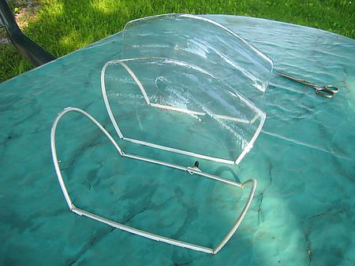
Canopy frame in front, broken canopy in center, and newly finished canopy in rear. Trimmed with scissors.
Nebesia kostra v čele, porušená klenba v centre, a čerstvo hotový nebesia v zadnej časti. Ozdobený nožnicami.
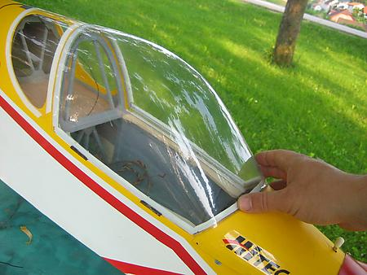
New canopy on the model! It is allmost hard to believe, that this canopy was made using above described simple technology.

New nebesia na vzore! To je všetko-najviac tvrdý verí, že tento nebesia bol nás nad popísaným jednoduchým technológia.

Some aditional info:
Once I coat the mold with a thin layer of grease, so the plastic can strech over the mold without unnecessarry friction. That way, the thicknes of finished product is more even. The result was very well.

Once, when pick up the plastic from owen, it fall down on the floor from my hands, as I was clumsy with gloves. When I finally pick it up from the floor and try to streech it over a mold it was already not hot enough. I was thinking, that I destroyed the plastic. But I return it into owen and repeat the process. I made a perfect canopy second time. So, dont be affraid if it will not goes at very first attempt. You can use the same plastic again, even if looks used...

And that is all you need to do!
Mitja, Ultralajt
Niektorý vchod informácia:
Raz ja natriem charakter s tenkou vrstvou tuku, tak plastika môže strech nad charakter bez unnecessarry trenia. Tadiaľ, vrstvy z hotového výrobku je viacej dokonca. Výsledok bol veľmi dobre.

raz, keď vyzdvihne plastika z bola dlžná, to spadnú na podlahu z mojich rúk, pretože som bol nemotorný s rukavicami. Keď ja konečne vyzdvihnem to z podlahy a skúša streech to nad charakter to nebolo už nie horúce dosť. Ja som premýšľal, že ja som zrušil plastiku. Ale ja navrátim to do je dlžné a opakovať proces. Ja som urobil perfektný nebesia druhýkrát. tak, vziať na seba byť affraid ak to nenapadne vôbec prvý pokus. Môžete použijete ten istý plastický zasa, aj keď výzory používali...

A to je všetko vy potrebujete urobíte!
Mitja, Ultralajt

